Creating a Git Repository

## **Accessing the AWS Cloud9 IDE**

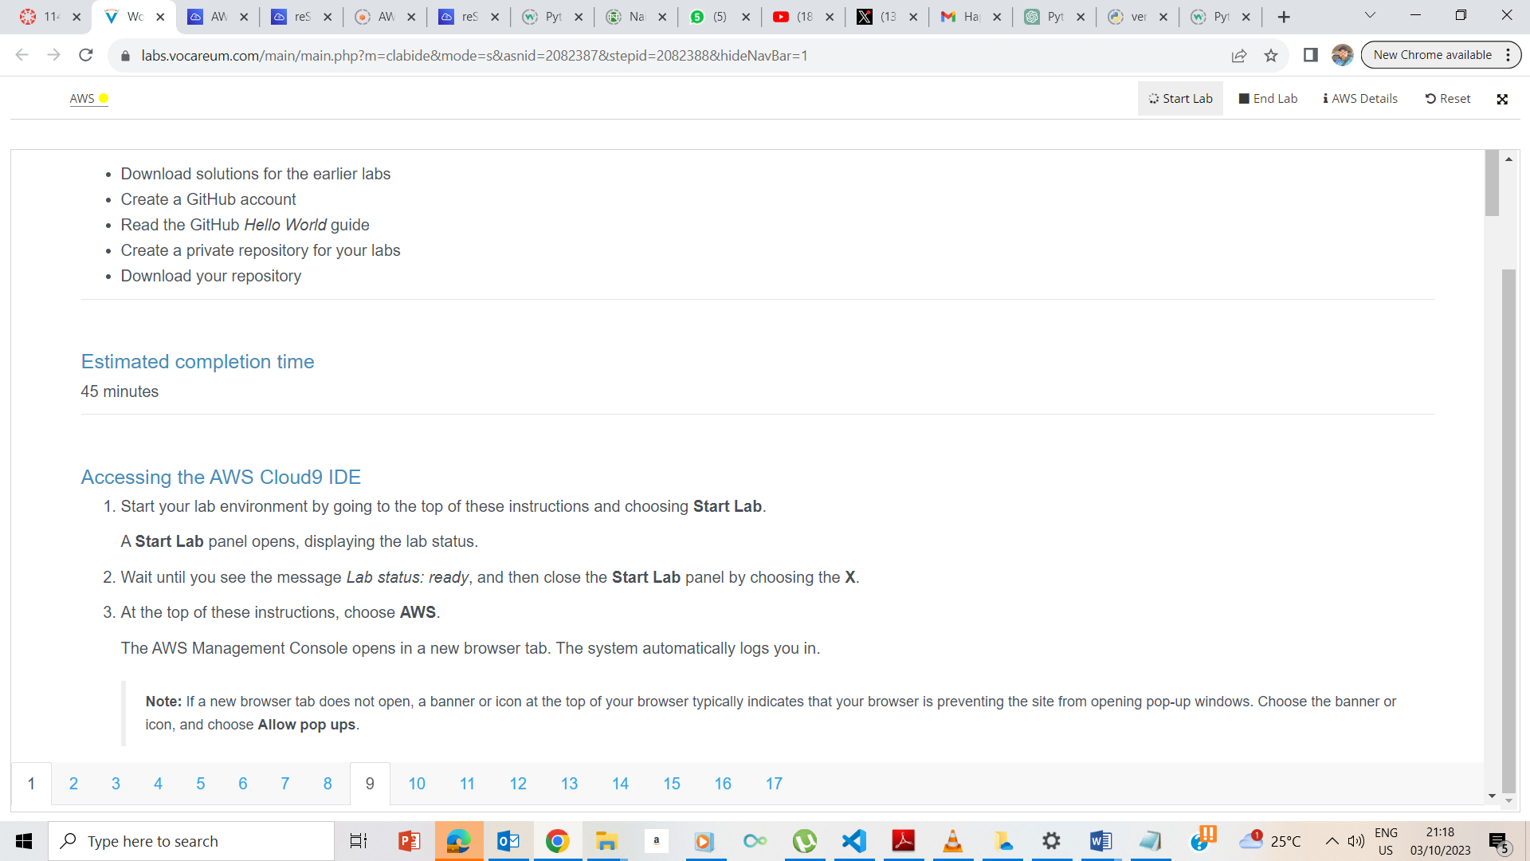

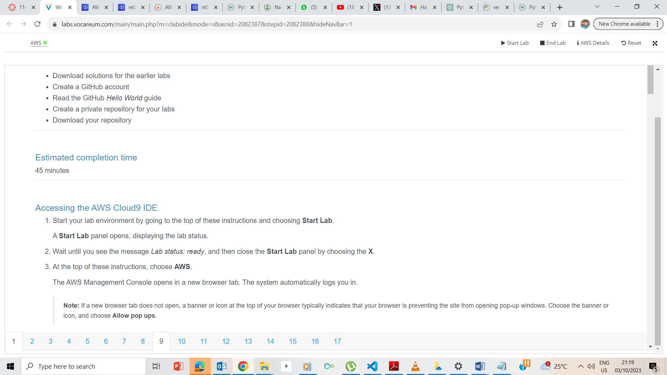

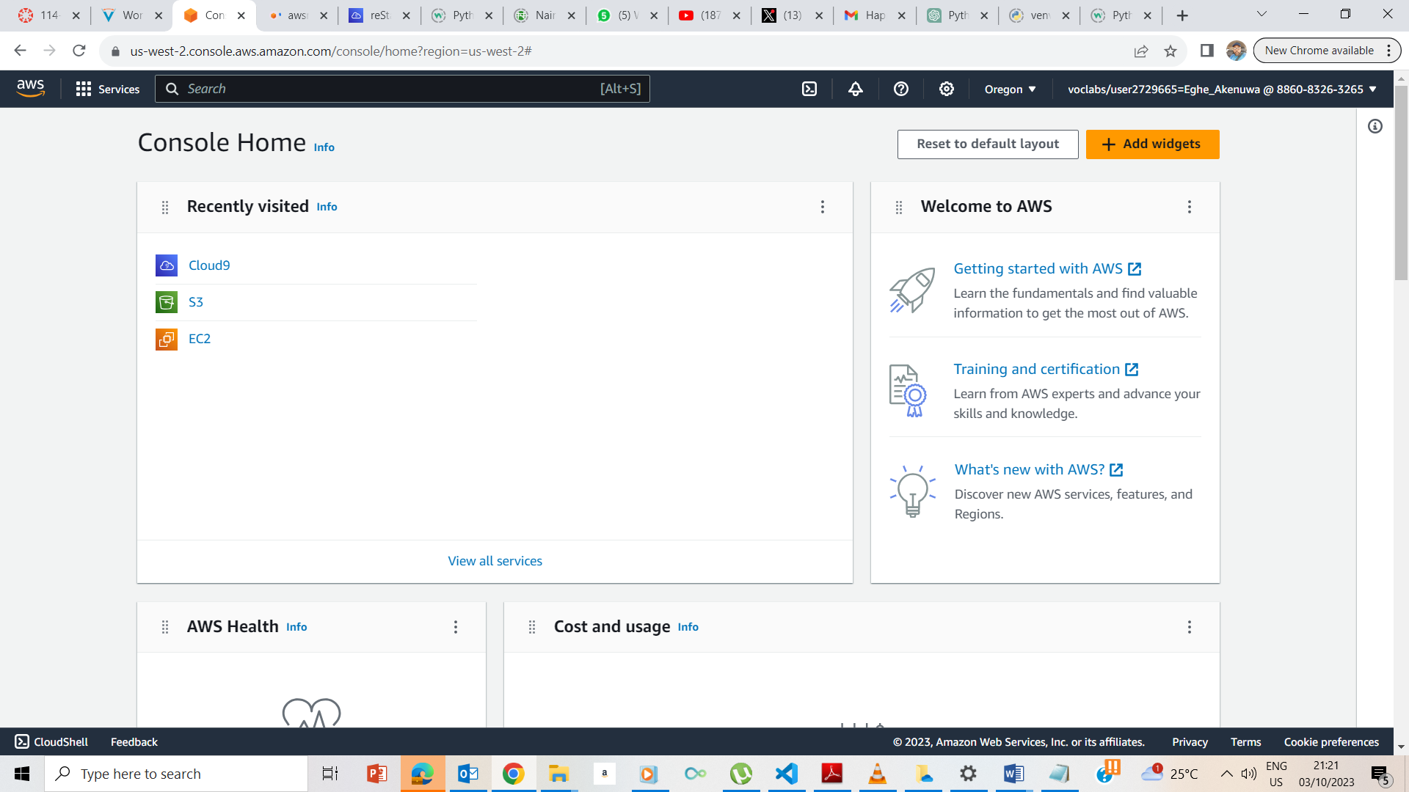

The AWS button took us to the AWS Management console. I now pressed the Cloud9 icon.

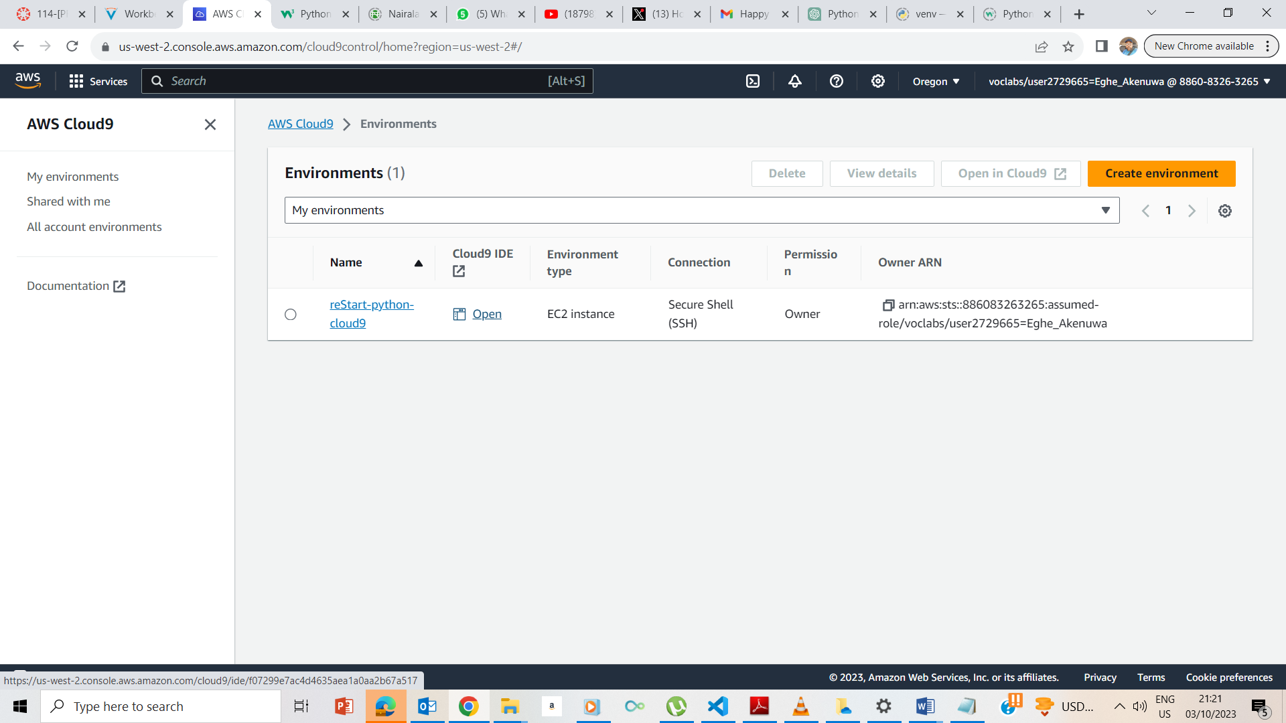

On the Cloud9 icon, I clicked ob the Open IDE

## **Exercise 1: Downloading your Python files from the previous labs**

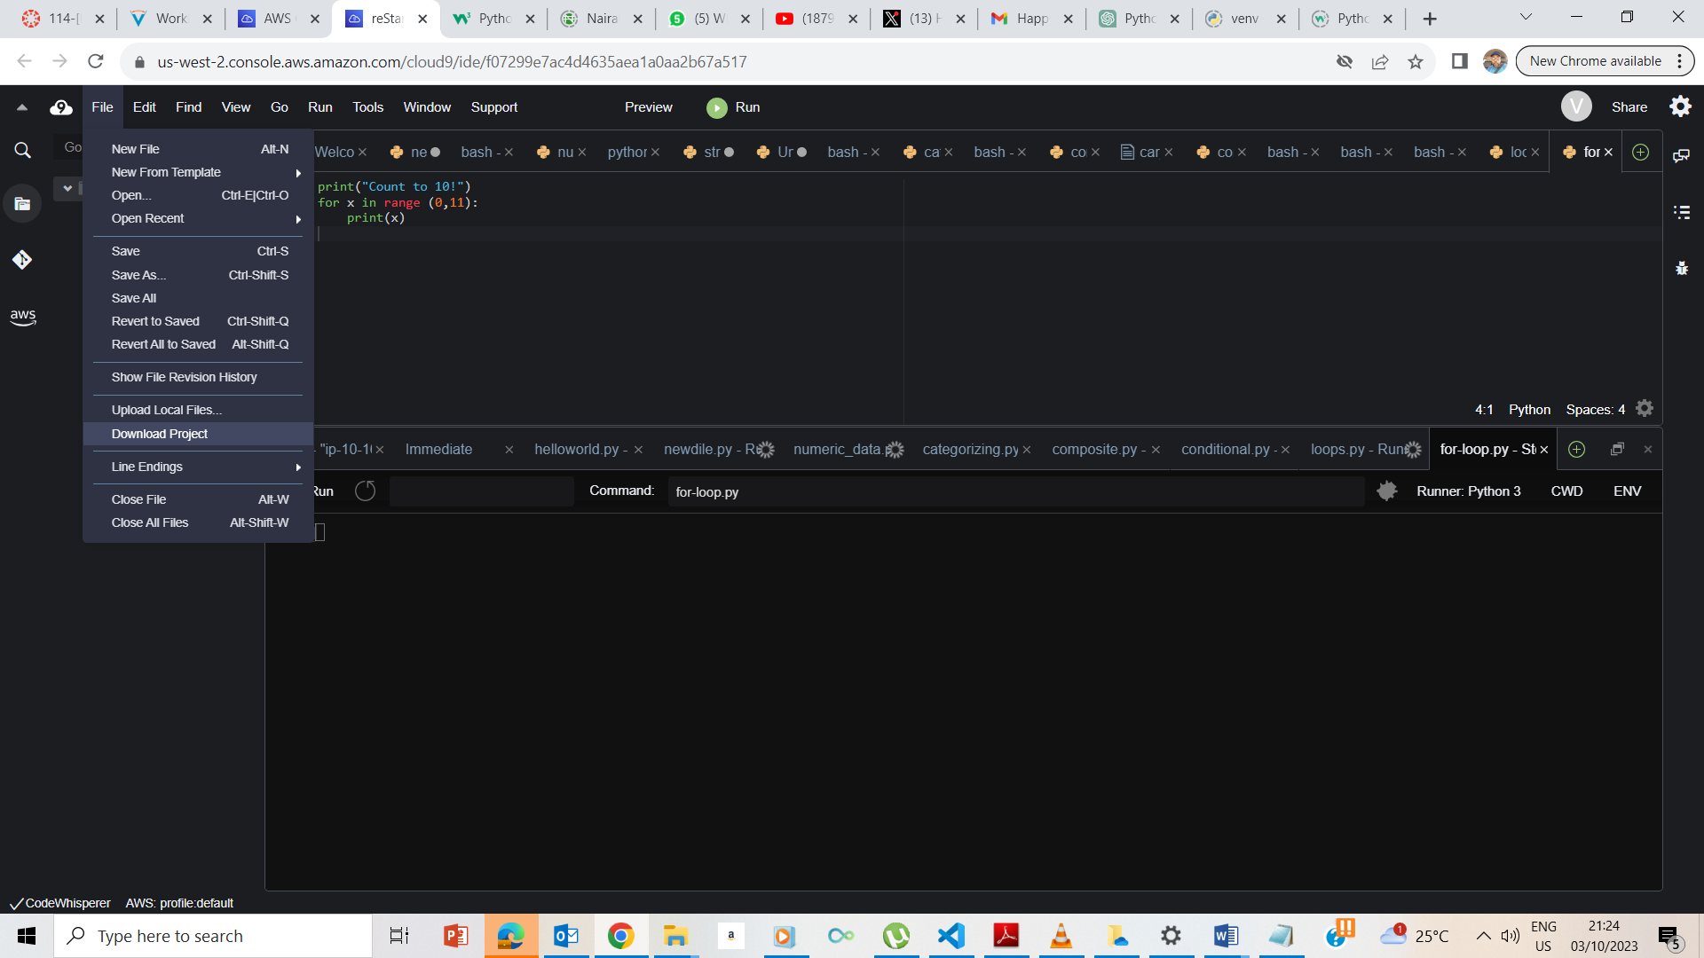

I clicked on File the Download Project.

## **Exercise 2: Creating a GitHub account**

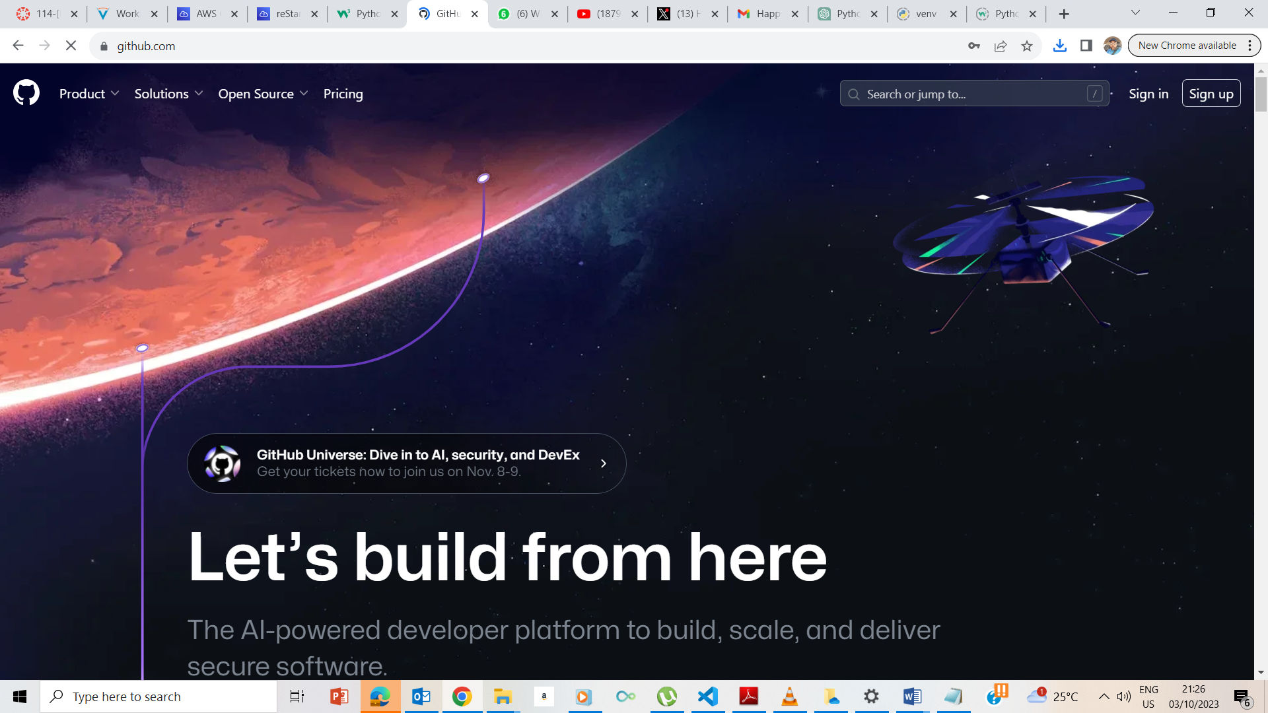

I went [www.github.com](http://www.github.com) page ad created an account.

## **Exercise 3: Reading the GitHub Hello World Guide**

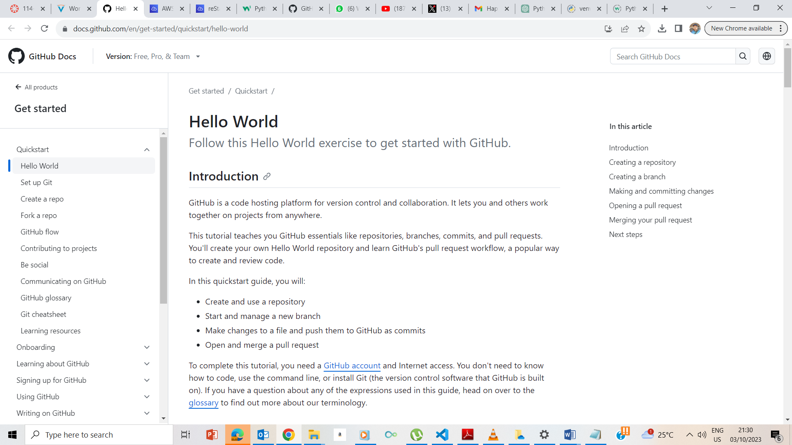

I read about the hello World at this github address - <https://docs.github.com/en/get-started/quickstart/hello-world>

## **Exercise 4: Creating a private repository**

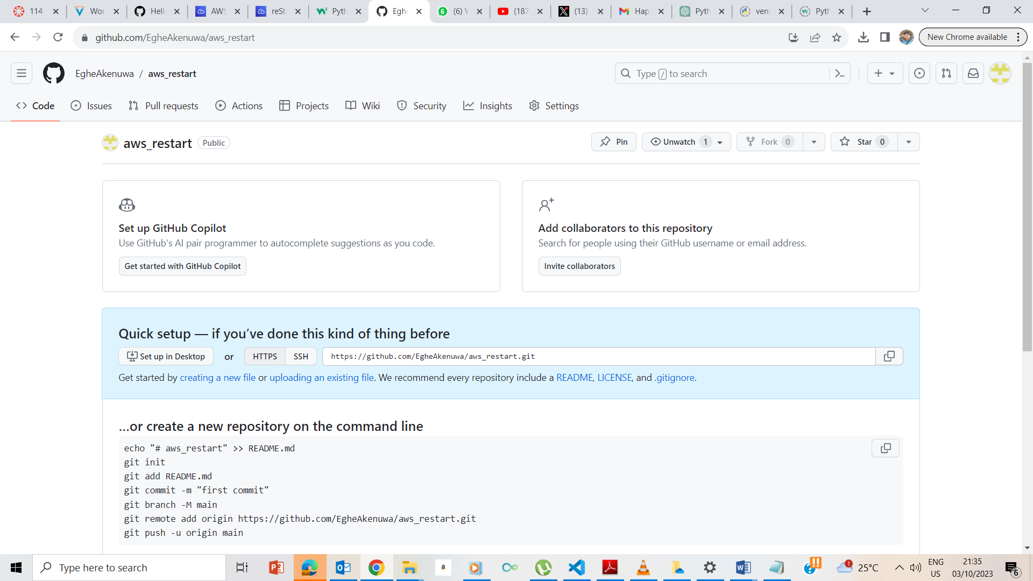

I created a new repository named aws_restart.

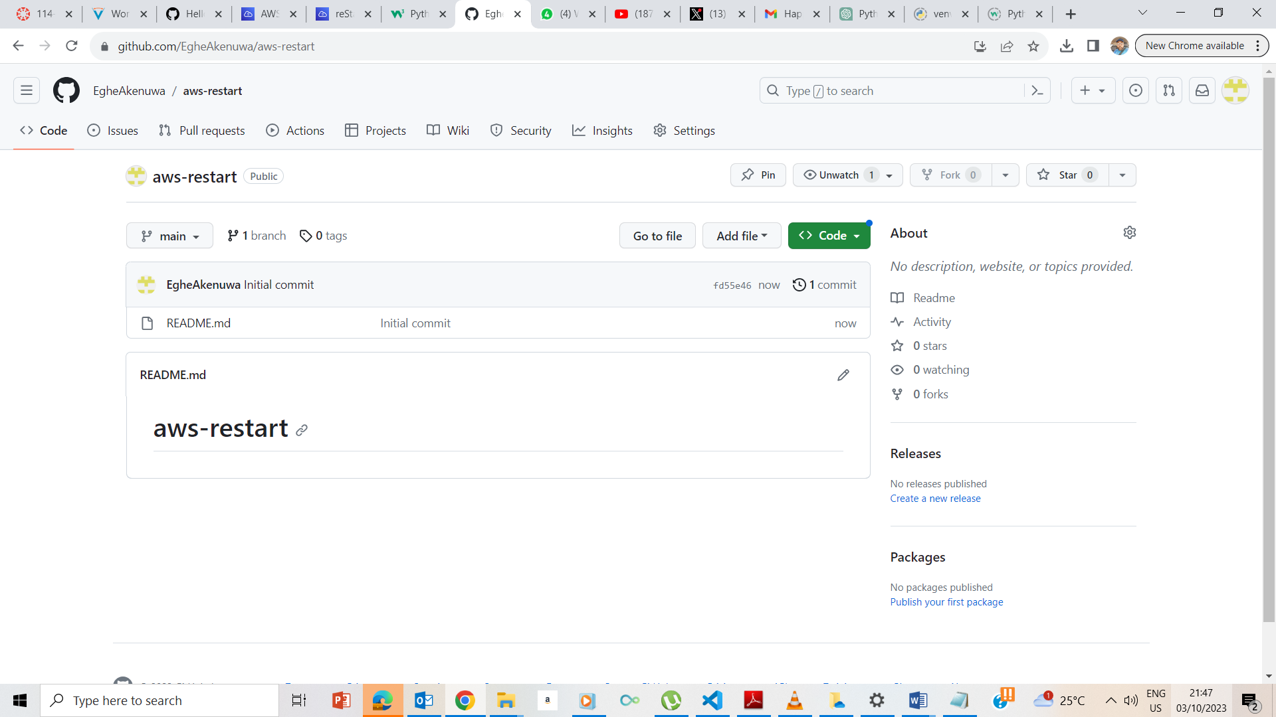

Readme file.

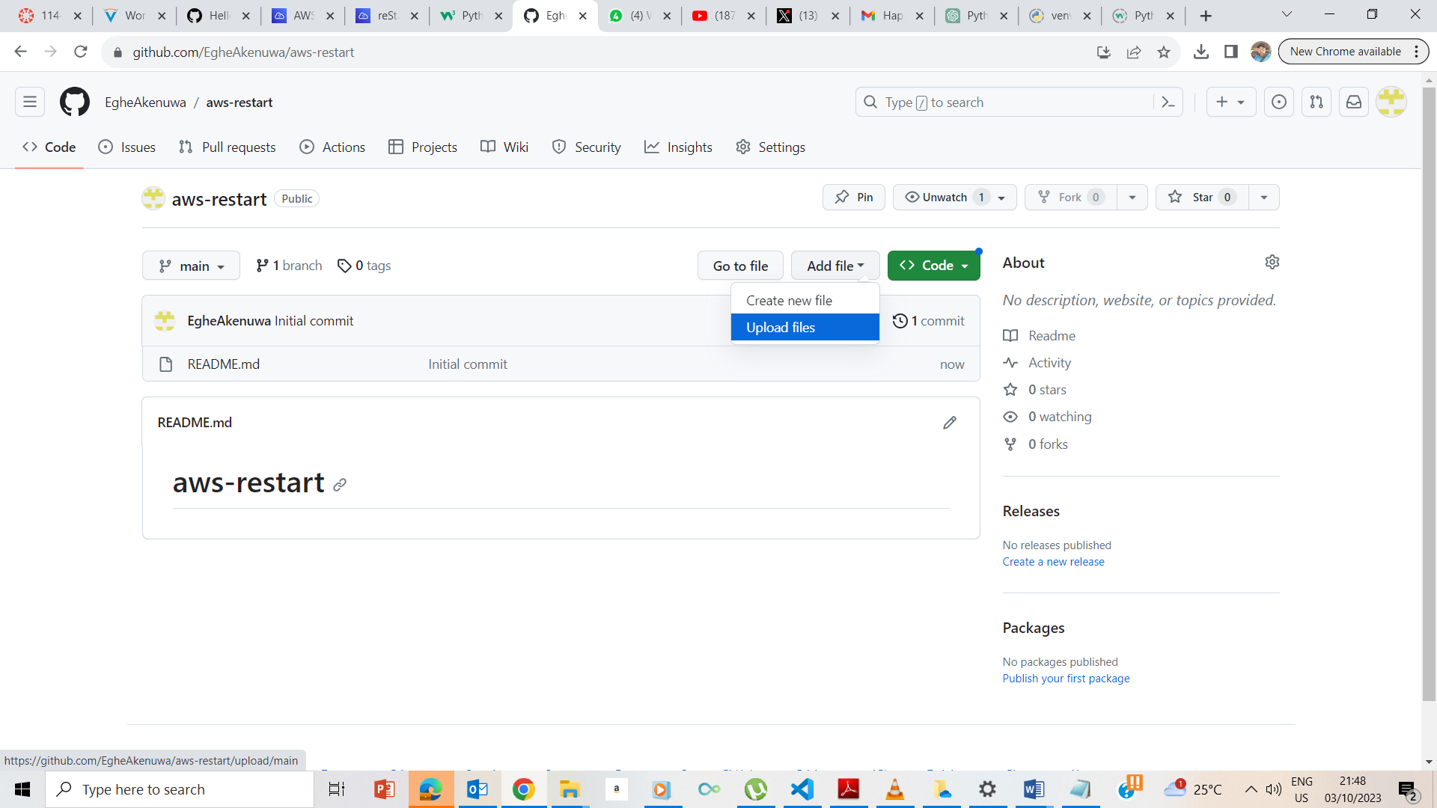

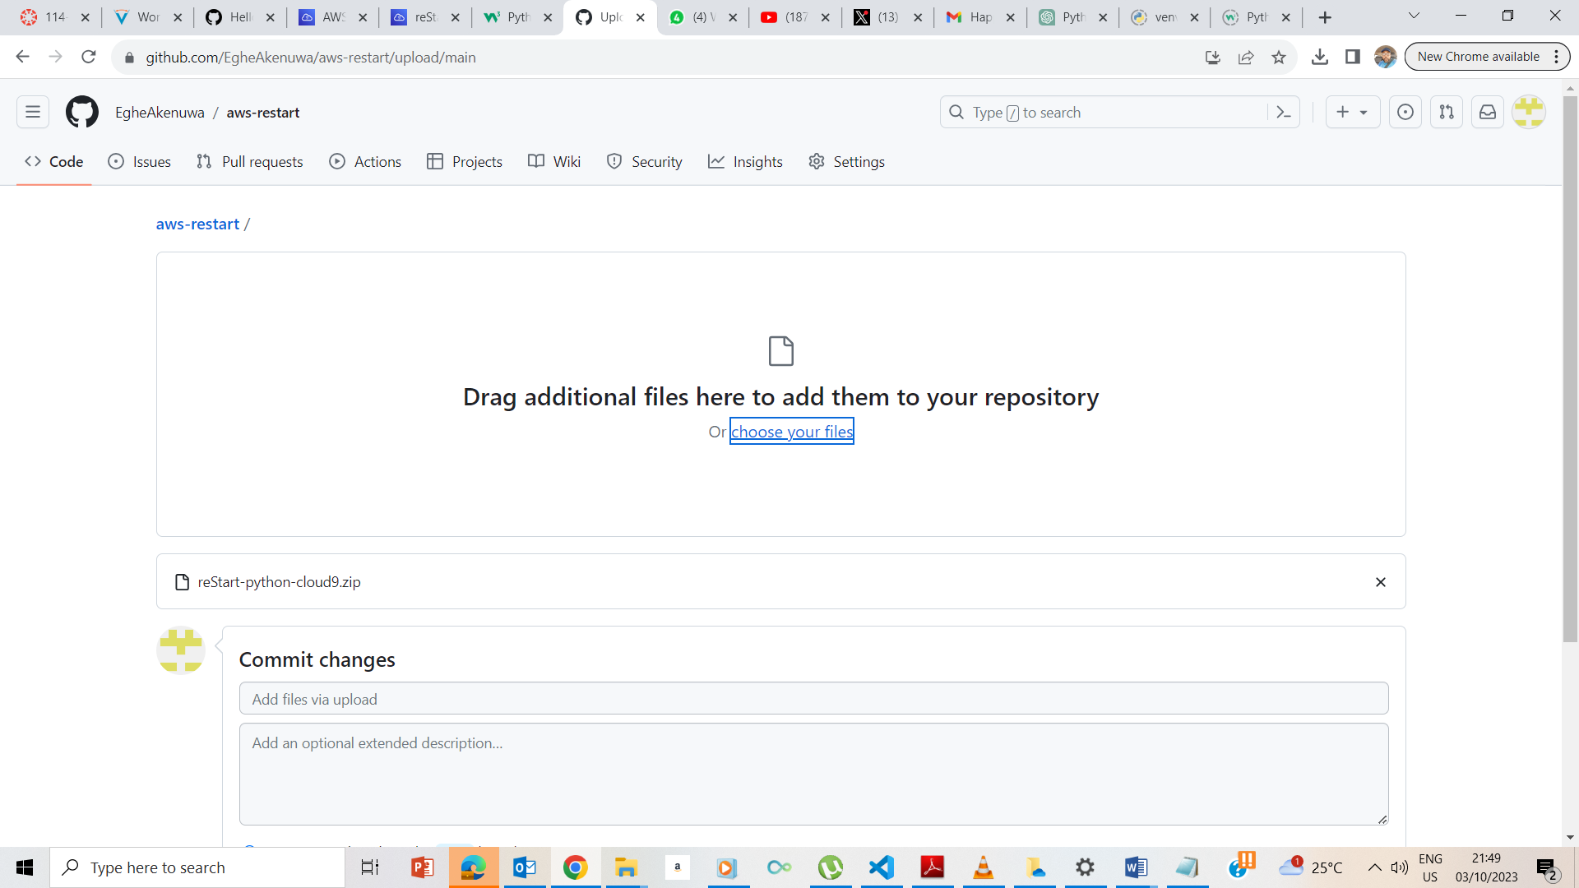

Uploaded the file I downloaded earlier.

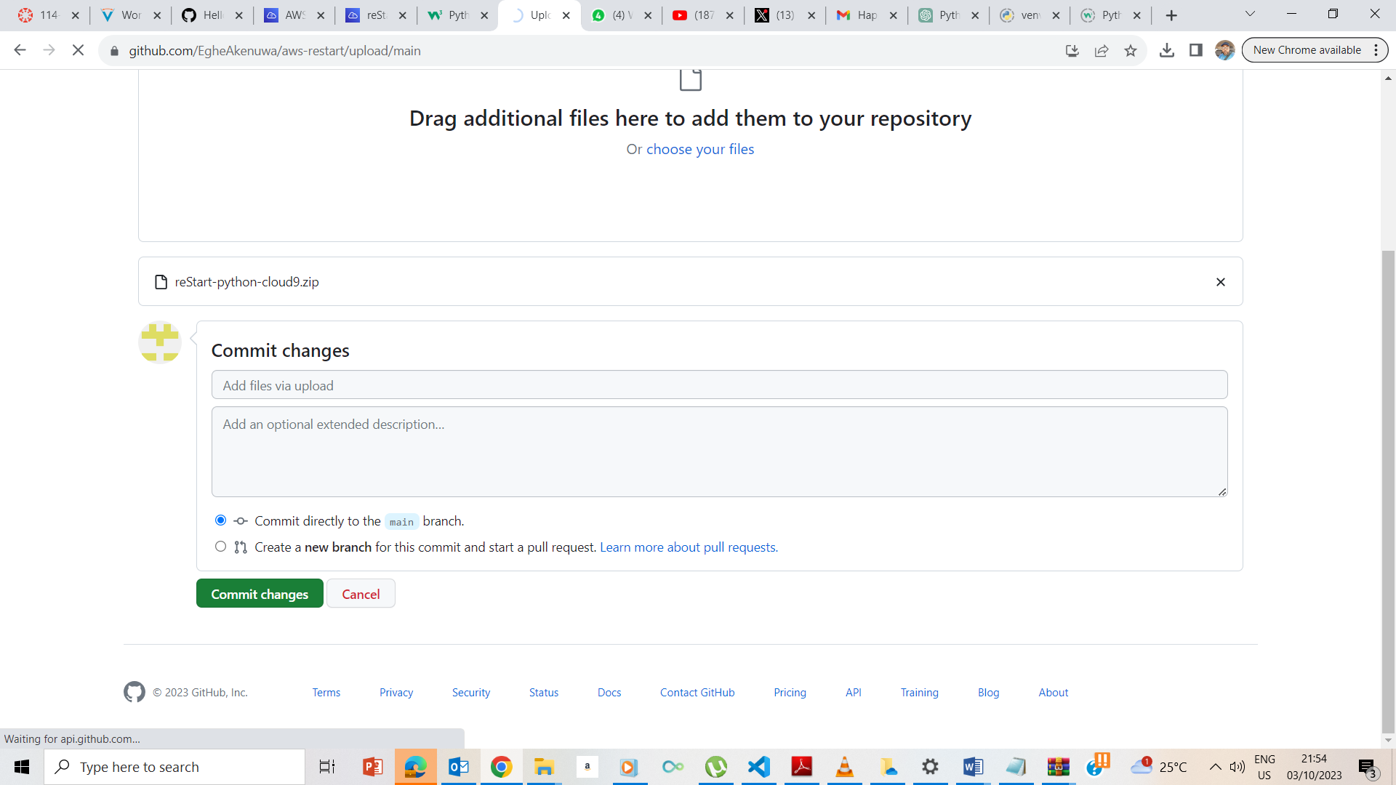

Committed to the changes

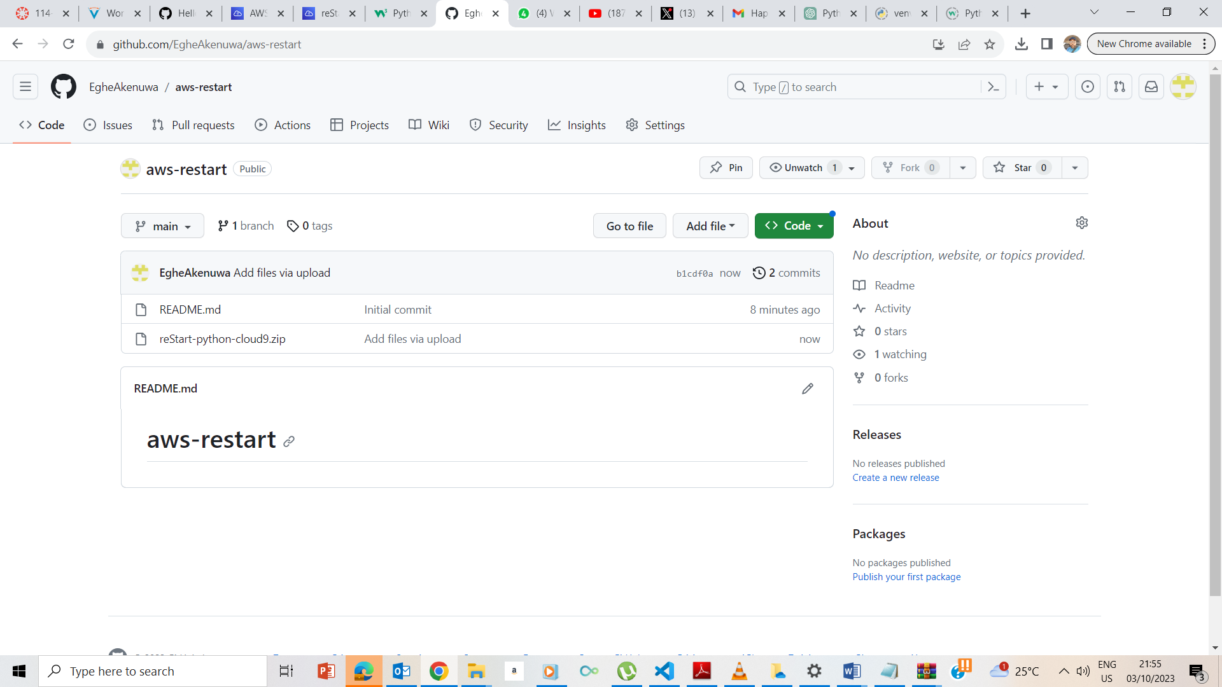

Zip file uploaded.

## **Exercise 5: Downloading a repository**

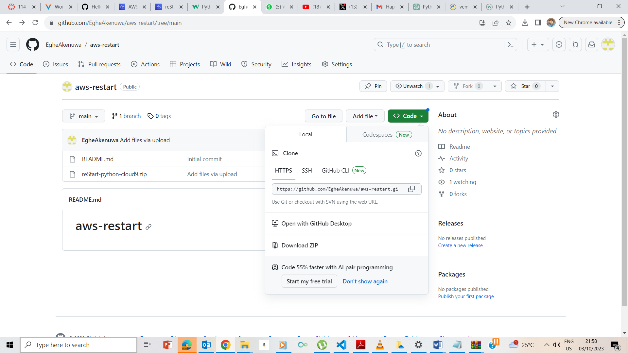

I clicked on download zip

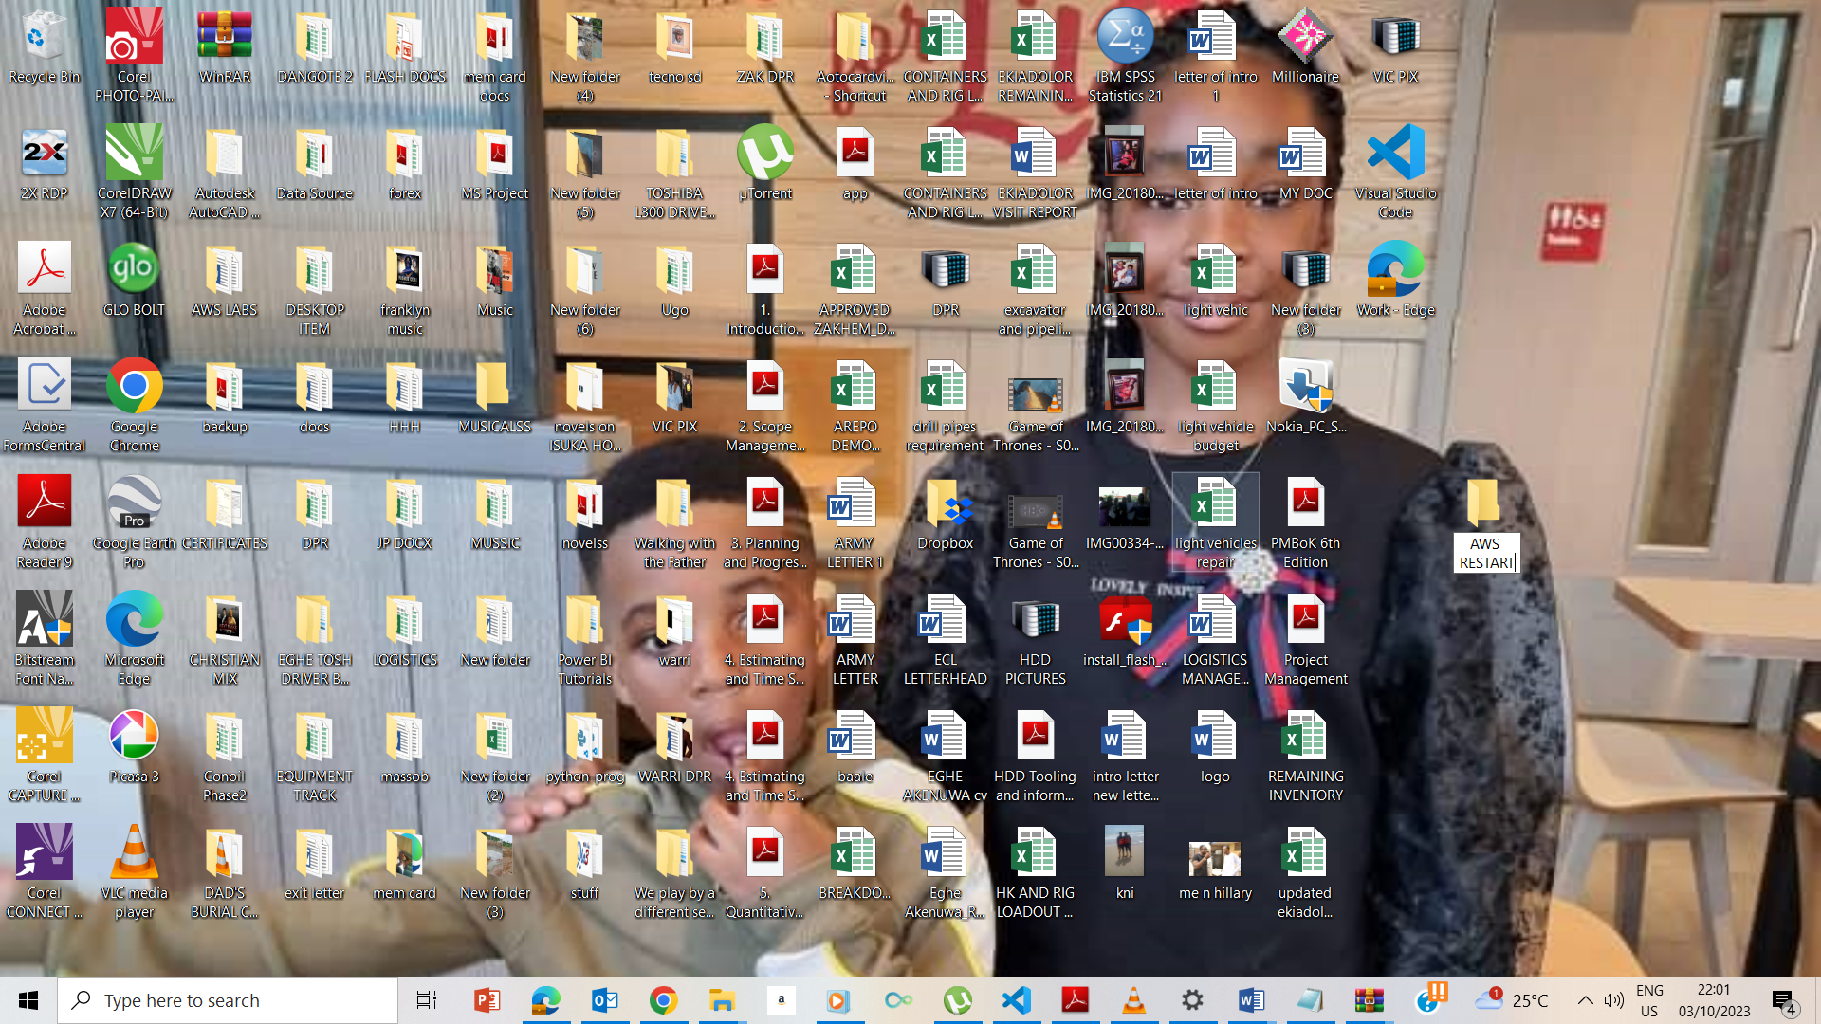

Created a folder called AWS Restart

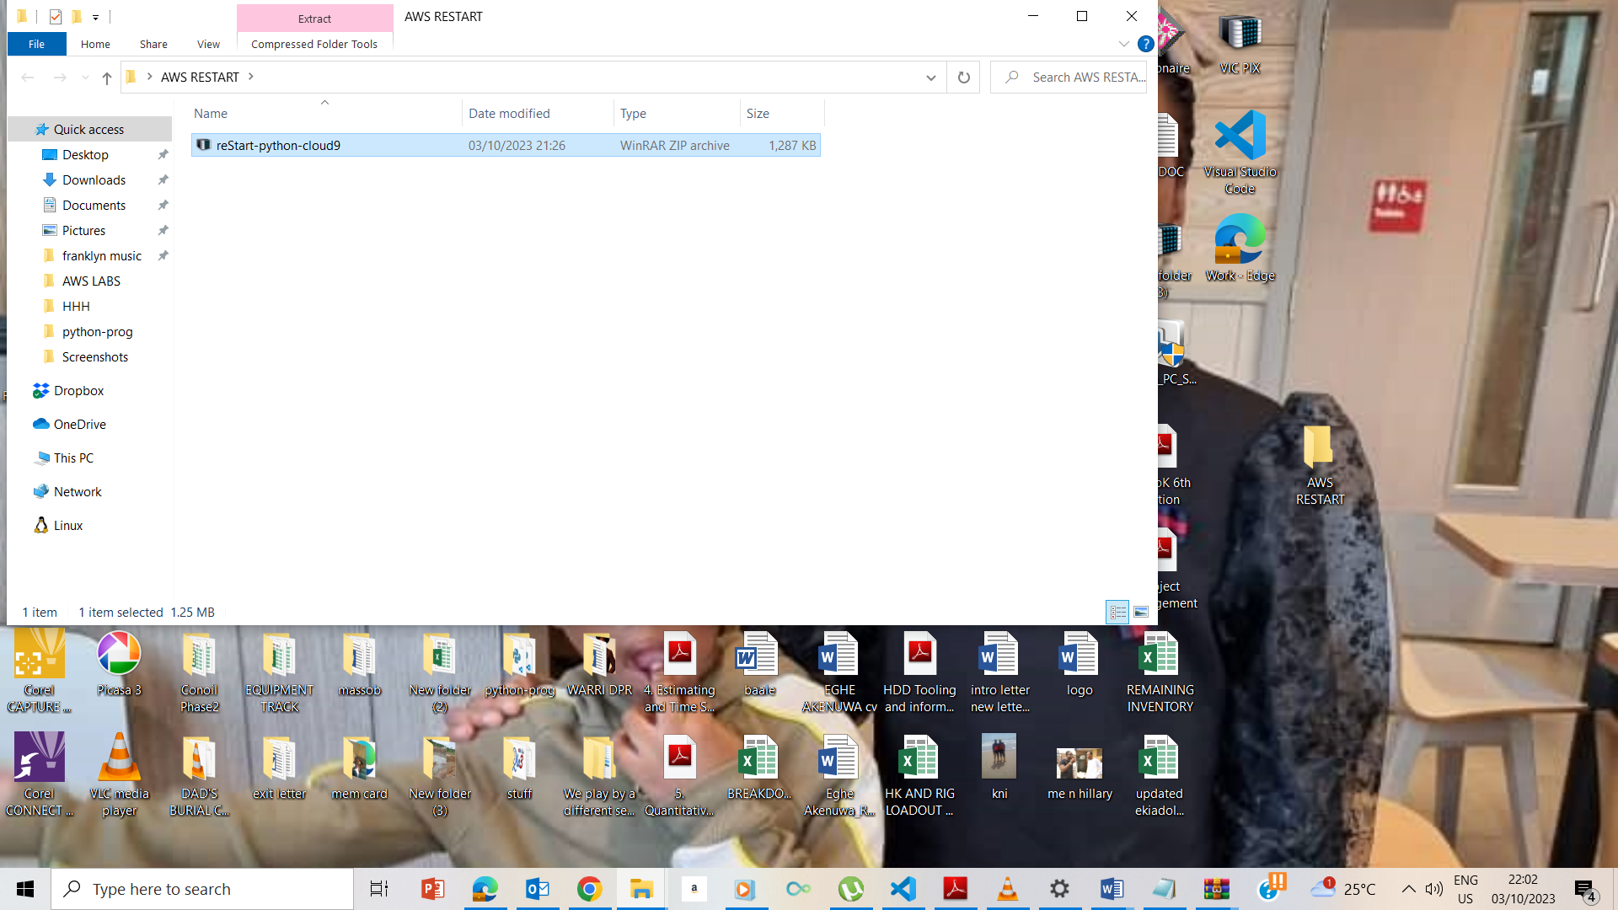

Moved the zip file to the AWS folder

## **End Lab**

